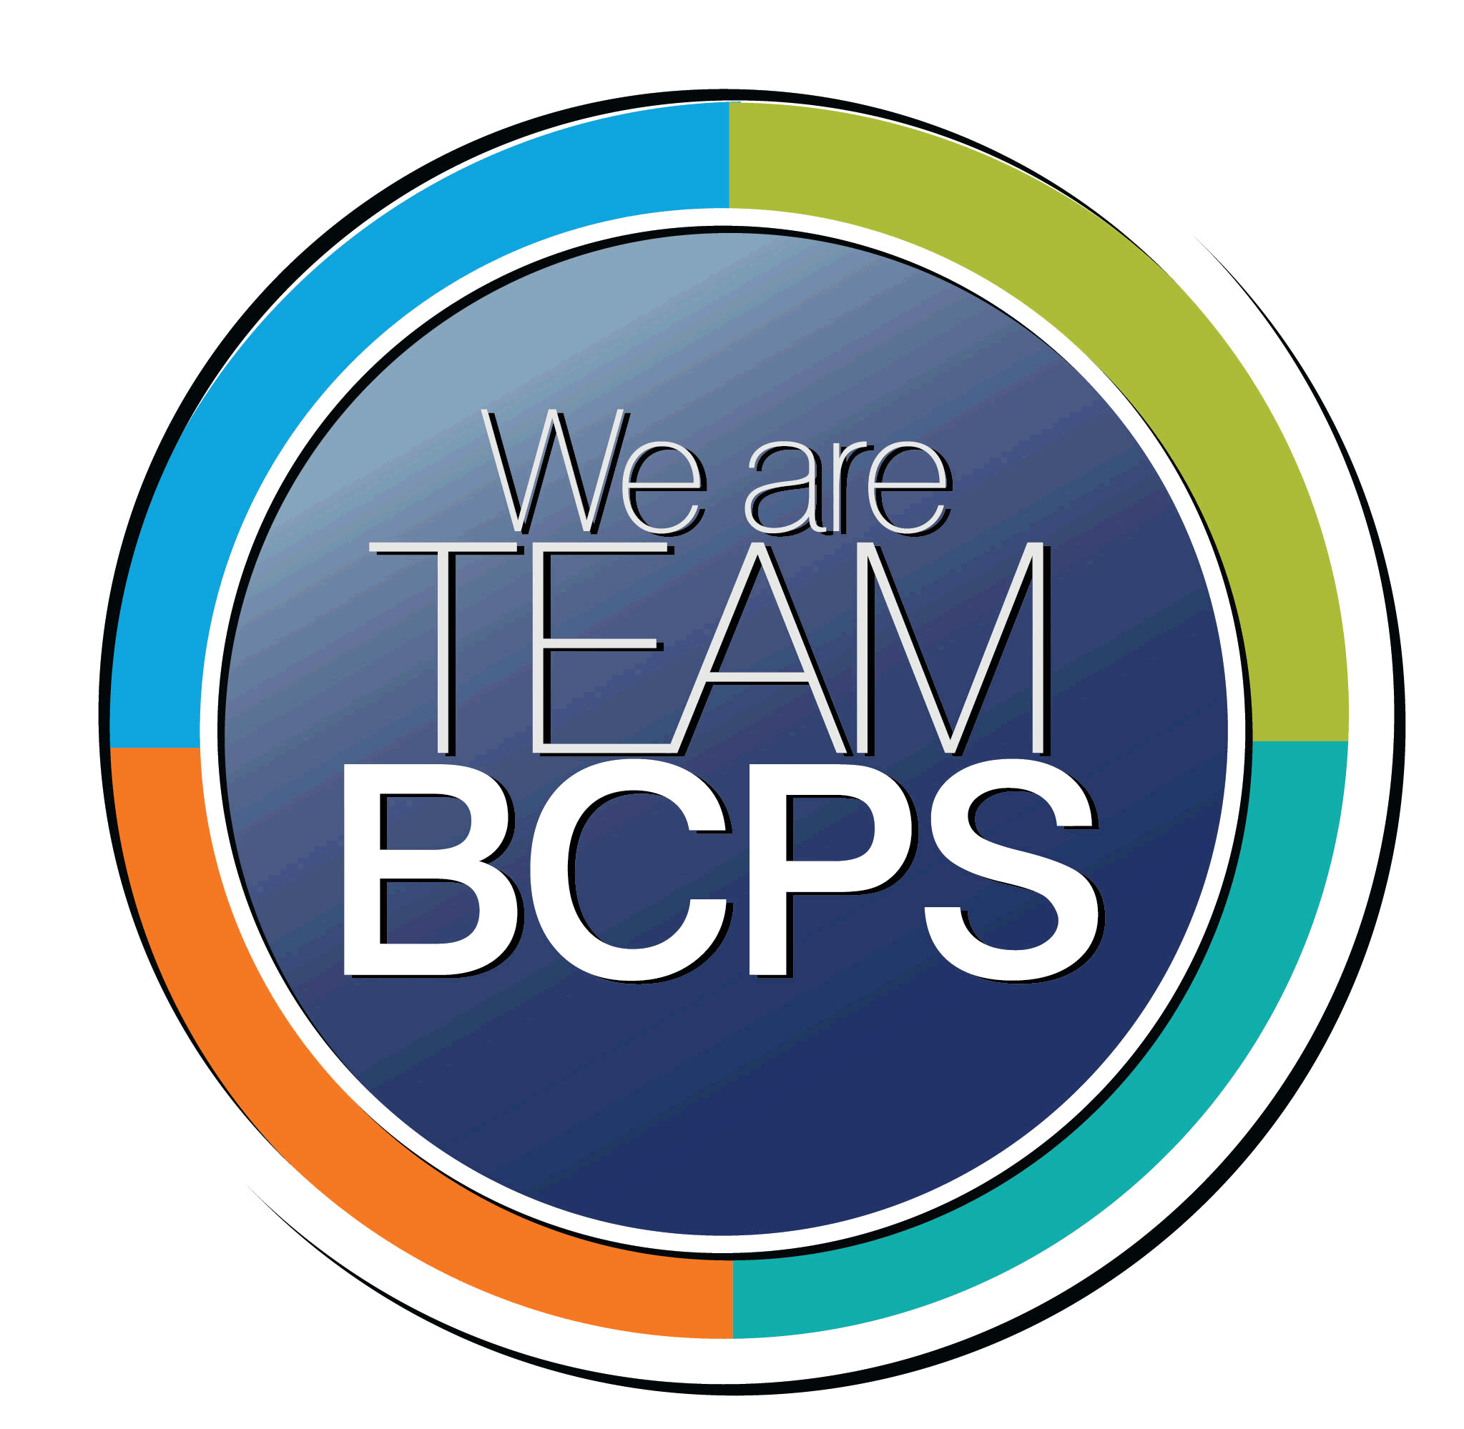 **Schoolwide Positive Behavior Plan** 

**Baltimore County Public Schools**

**Date Completed: 8/28/2022 School Year 2022-2023**

**School: Chesapeake High School**

|  |
| --- |
| **Section 1: Initial Steps** |
|  |
| **School Climate Team** |
| *Identify members of a School Climate Team (consider a representative selection of members). The team meets initially to examine equity concerns and data and to develop the Schoolwide Positive Behavior Plan. The team should then meet monthly (minimum quarterly) to assess the effectiveness of the SWPBP on an ongoing basis.* |
| Amy Tyler, Principal  Juan Stepter, AP  Amanda Furst, AP  Holly Coleman, AP  Michelle Bell, School Counseling DC  Lindsey Withrow, School Counselor  Jillian Ganley, School Counselor  Mary Roberts, Social Worker  Scott McGowan, SEL  Adrienne Dodson, Spec DC  Gina Veiner, PPW |
| **Equity Lens** |
| *Through an equity lens, identify what the data indicate about the social-emotional needs of students and the support provided by staff members relative to disproportionality between student groups, especially for African Americans or students receiving special education. Also consider the school’s population with regard to ELL, Latinx, and/or other student groups. (Information may be from School Data Story)* |
| Equity group review data provided by DRAA, climate data, and Data Story to analyze disproportionality between or among student groups. |
| **Data Analysis** |
| *Summarize what the data tell about the school climate. (Information from School Data Story)* |
| At our school during the 2021 – 2022 SY enrollment included 970 students and our demographics are as follows: 553 Black/African American students, 221 White students, 130 Hispanic students, 52 Two or More Races student and 10 Asian students.  The overall enrollment count has decreased since 2020-2021. During the same period, the number of Hispanic/Latino and Two or More Races students has increased while the number of Asian and White students and students who receive English Learner, Free and Reduced Meals, and Special Education services has decreased.  Black/African American female students are suspended at rates higher than their non-Black/African American female peers. The suspension rate risk ratio for Black/African American female students at Chesapeake High is greater than the same measure for all BCPS high schools.  Black/African American male students are suspended at rates higher than their non- Black/African American male peers. The suspension rate risk ratio for Black/African American male students at Chesapeake High is less than the same measure for all BCPS high schools.  Students eligible for Free and Reduced Meals are suspended at rates higher than their non-Free and Reduced Meals peers. The suspension rate risk ratio for Free and Reduced Meals eligible students at Chesapeake High is less than the same measure for all BCPS high schools. |
| **Climate Goals** |
| *Identify the school’s goals in improving the social-emotional climate of the building. (Information from School Progress Plan)* |
| Educators will examine and interrogate their personal biases to become aware of the ways in which their own cultural experiences influence the conditions and learning opportunities that they create for students (TSI: SE, MU, ED)  Teachers explicitly teach and model social emotional learning skills and strategies and integrate them into academic content. (TSI: SE, MU, ED) |
| **Section 2: Developing and Teaching Expectations** |
|  |
| **Expectations Defined** |
| *Identify a School Code of Conduct with 3-5 positively stated school expectations. Develop a way to communicate the identified rules, based on the schoolwide expectations, for specific settings within the school building. Expectations should be clearly stated, communicated, taught, and frequently referenced.* |
| Developing behaviors from our core values with Instructional Leadership Team.  Code of Conduct: Respectful, Responsible, Ready to Learn |
| **Classroom Plan for Teaching and Reinforcing Expectations, Routines, and Procedures** |
| *Teachers develop visuals to communicate culturally relevant classroom expectations, routines, and procedures based upon the schoolwide expectations. Educators explicitly teach expectations, routines, and procedures. The school staff recognize and reinforce expected and positive behavior. Teachers identify encouraging procedures and corrective procedures for their classrooms.* |
| CHS expectations, routines, and procedures are centered in our core values of equity, collaboration, flexibility, and authenticity. Teachers translate the core values into meaningful procedures and habits for their individual classrooms. CHS will developschool wide plan that provide expectations for common areas for teachers and students to refer too. |
| **Family/Community Engagement** |
| *Identify how the Schoolwide Positive Behavior Plan, the schoolwide expectations, and/or interventions will be communicated and shared with families. Consider how to include family and student voice in the initial plan and in evaluating the plan throughout the year.* |
| We value student voice in our planning. We plan to hold student forums that allow to gather feedback throughout the year. Schoolwide expectations are communicated to families through newsletters. |
| **Section 3: Developing Interventions and Supporting Students** |
|  |
| **Resource Mapping of MTSS** |
| *Identify the evidence-based practices and interventions offered at Tier 1, Tier 2, and Tier 3 to support all students. Consider what culturally responsive interventions the school requires to meet the specific needs of the students.* |
| Tier 1 supports are centered in school wide and classroom expectations. They are established and provide support preventing unwanted behaviors. Tier 2 supports include more intensive one on one tailored plans for students. These could include but are not limited to social skills groups, self-management with behavior management sheets, and increased academic supports. Tier 3 supports are the most intensive and individualized to support behavior and academic outcomes. |
| **Social-Emotional Learning** |
| *Identify the specific evidence-based social-emotional learning skill development practices the school will implement during the school year. Consider the importance of trauma-informed care, mental health awareness, level of students’ coping skills, etc. Determine how the social-emotional learning and the SEL competencies will be integrated into the school’s programming. Consider the need for any training the staff members may require.* |
| Restorative Practice (questioning/circles), social awareness, <https://casel.org/sel-framework/>, 3 Signature practices. Teachers will center student’s identities, strengths, interests, and needs in order to make instruction accessible |
| **Character Education** |
| *Determine how specific evidence-based character education learning will be infused into the school’s programming to promote positive behavior and ethical decision-making. Character education will be culturally responsive and co-created with diverse stakeholders. Consider the need for any training the staff members may require.* |
| Culturally responsive teaching (CRT): Teachers will center student’s identities, strengths, interests, and needs in order to make instruction accessible. Instruction will reflect culturally relevant pedagogy and strategies |
| **Professional Development for Staff** |
| *Identify the professional development that will be offered to staff members throughout the year in order to support their knowledge, skill development, and implementation of the interventions selected, the character education learning, and social-emotional learning practices. Specify the schedule for professional development and how to obtain teacher feedback during the year to address their concerns and areas in which they want/need more information. (Information from School Progress Plan.)* |
| Restorative Practices/Culturally responsive teaching (AVID CRT Book) |
| **Section 4: Supporting and Responding to Student Behavior** |
|  |
| **Recognitions/Incentives** |
| *Identify a variety of positive consequences, acknowledgements, recognitions, and/or incentives that are linked to the behavioral expectations and rules. Develop a system for implementing the positive acknowledgements consistently in school settings. Consider how to monitor who is being recognized and who is not being recognized and whether explicit or implicit biases may be occurring.* |
| CHS has a spirit committee and PBIS supports that provide acknowledgements and recognitions. The spirit committee focuses on school wide recognitions and celebrations that provide our community with opportunities to celebrate being a Bayhawk. Content departments have monthly and quarterly celebration to highlight academic achievement. |
| **Hierarchy for Behavioral Referrals and Consequences** |
| *Identify the behaviors that are teacher-managed, behaviors referred to resource staff, and behaviors referred to administration. Refer to the BCPS Student Handbook for teacher and administrator-led interventions. Consider how unsafe behaviors will be addressed.* |
| CHS identifies behaviors that are teacher-managed and referred to other staff according to the BCPS handbook. |
| **Response for Intensive Behaviors** |
| *Identify a hierarchy of responses to intensive behaviors (i.e., emergency/crisis management/threat assessment/unsafe behaviors) including interventions and supports. Indicate which school staff members will respond as well as procedures and training as needed.* |
| CHS has a management and emergency team that can support the safety of the building. All staff is trained in ALICE for effective responses for an unsafe building. |
| **Monitoring the Schoolwide Positive Behavior Plan/Data Analysis** |
| *Identify the data that will be collected and reviewed by the School Climate Team in order to identify behavior trends, patterns, action steps, and interventions using a problem-solving strategy. Consider having a uniform referral form for staff to complete to document referrals to administration. Consider how teachers should document classroom-managed concerns/behaviors/difficulties. (Information from School Progress Plan.)* |
| CHS has utilized the BCPS system of FOCUS to input and collect behavior information. Teachers’ referrals are monitored daily. Behavior/attendance data is gathered from the FOCUS system to identify trends and students that need support. |
| **Section 5: Miscellaneous Content/Components** |
| Educators will examine and interrogate their personal biases to become aware of the ways in which their own cultural experiences influence the conditions and learning opportunities that they create for students |